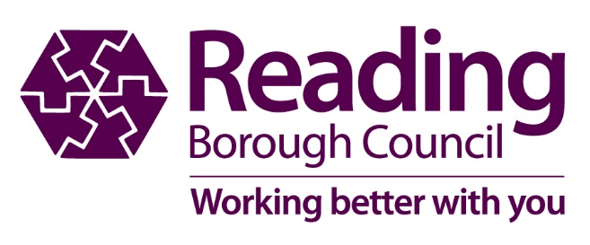

Reading Cultural Education Partnership Evaluation

Evaluation of 2016-19 CEP Strategy

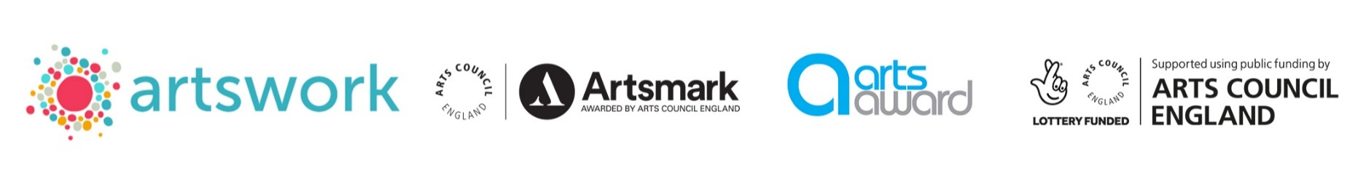
Contents
- Context
- Review of previous strategy
- Survey
- Results of objectives
- Results of consultation
Appendices
Appendix 1 Terms of Reference
Appendix 2 SWOT analysis
Appendix 3 Arts Award and Artsmark statistics
Appendix 4 Survey data
Appendix 5 Consultation workshop feedback

Executive Summary
School Engagement
2016 to 2019 Key Successes
Young person engagement
95% of Schools in Reading engaged with cultural organisations and/or programmes
95% of Schools in Reading engaged with cultural organisations and/or programmes
265,532 young people and children engaged
Benefits
Best practice sharing and coordination of cultural programmes
Partnerships between cultural organisations and non-cultural organisations
Partnership projects between cultural organisations
£97,700 additional funding achieved through the CEP
1,444 Arts Awards achieved by young people and children
10 schools joined the Schools Connect programme and regularly engage
17 schools registered for Artsmark

Evaluation of 2016-19

Context
  - Reading CEP Strategy 2016-19
The previous strategy outlined the following overarching aim and objectives:
Overarching Aim:
To allow every child and young person in Reading to have the opportunity to aspire, achieve and participate in high quality arts and culture, and to develop a collaborative, sustainable infrastructure to maintain such engagement.
Definition: the work of the CEP focuses on children and young people aged 0-19 and on vulnerable young people up to the age of 25.
Objectives:
- By August 2019 5,000 children and young people who were previously unlikely to engage with or participate in arts and culture will have engaged with and participated in an activity*
- Over the term of the CEP Action Plan 1,500 young people will have undertaken training, and achieved skills and appropriate accreditation, making them ready to seek employment in the cultural sector, or to use creative skills in their chosen employment field**
- Between September 2016 and August 2019 1,500 children and young people in Reading will have engaged in Arts Award with at least 750 achieving accreditation at one or more levels
- Over the term of the CEP Action Plan 30 schools and colleges in Reading will have gained Artsmark status
- Between September 2016 and August 2019 20+ partner organisations will actively participate, in collaboration, in delivering the CEP Action Plan
- By August 2019 a further 3 Year CEP Action Plan will have been developed and resources secured to maintain a sustainable infrastructure for comprehensive ongoing arts and cultural engagement and participation from Reading’s children and young people
* By targeting activity in areas of deprivation this objective can be focused and evaluated
**Meaning that young people from Reading will have achieved relevant accreditation through arts related degree programmes, BTEC Arts programmes, Silver or Gold Arts Awards, Level 5 or above Music Grades, specific and recognised theatre and dance awards, or equivalents

Review of 2016-2019 strategy

A consultation process was undertaken to evaluate the impact of the previous 3 years’ strategy and progress against its objectives.

The consultation consisted of:
- An initial meeting with CEP partner members
- A SWOT analysis
- A survey of Reading CEP partner members
- Telephone interviews with Reading CEP partner members
- A series of Lego® Serious Play® workshops led by Steve Christmas (Brick Creative) for partner members and groups of children and young people
The full gathered information from the consultation are included in the Appendices.

  - 4.1 Summary from survey responses and telephone interviews:
Feedback from the survey and interviews found that there had been significant levels of engagement in culture of children and young people as a result of the CEP. Responses also indicated a number of successes in meeting the objectives, with some key areas that could be developed further.

Significant Level of Engagement
- A good range of artforms is offered to children and young people, with only a few gaps in provision for digital arts and literature workshops;
- A good range of schools are engaged with: 95% of Reading schools engaged with cultural activity with CEP partners over the last 3 years;
- Reading Borough Council was key to the success of keeping momentum with the CEP;
- That there has been significant increase in numbers of children and young people engaging with culture and with Arts Award: between January 2016 and November 2018, 1,444 Arts Awards were achieved in Reading, with 1,355 (94%) being achieved through CEP partnerships (Source: Artswork figures, see Appendix 3)
- There is evidence of significant increase in collaborative working across the CEP partners, allowing leverage for increased resources and funding of projects. (For details of partnerships and investment, see Appendix 3)

Meeting the Objectives
  - The CEP has been very successful in increasing engagement with Arts Award and there is good progress towards increasing registration for Artsmark: 17 schools registered to work towards Artsmark, which is 26% of Reading schools (Artswork figures).
  - There is further work to do in increasing young people’s readiness for employment and reaching children and young people with barriers to participation;
  - The CEP has been successful in increasing collaboration between partners;
  - Some success has been achieved in securing resources, in particular capacity building programmes that could provide good practice to build on in the future.

The survey sought feedback from members of the Reading CEP on ‘what next’ for the partnership. The findings uncovered an appetite to explore ways for the Partnership to:

- Champion the Youth Voice - placing the needs of children and young people at the heart of everything we do and giving them a voice to address what is important to them;

- Be More Brave - going beyond our usual practice and being more innovative in order to meet the needs of children and young people;

- Adapt to a changing landscape - what will the national and local cultural landscape look like in 3 years’ time? What can the Reading CEP achieve within this landscape?

  - 4.2 Results of consultation Lego® Serious Play® workshops
Following the survey, key themes to consider were drawn out and these formed the basis of the next stage of consultation, the Lego® Serious Play® Workshops, facilitated by the Steve Christmas (Brick Creative). The consultation sessions were also informed by the new draft Ten Year Strategy produced by Arts Council England, in order to ensure that the strategy was relevant to the wider cultural landscape.
3 questions were identified for the consultation group to consider:
- Creative people: What will the cultural landscape of Reading look like 3 years from now that enables ALL children and young people to develop & express creativity throughout their lives?

- Cultural communities: 3 years from now, how will culture and creativity have a broader impact on children and young people?

- A creative and cultural country: What does an innovative and collaborative CEP look like 3 years from now?
Attendees at the workshop then used Lego® to work together on building their vision, and from this they were able to articulate how they had explored the questions and were then able to identify a number of objectives for each of the three themes.

The main themes and discussions identified in this area were:

- Creative people: What will the cultural landscape of Reading look like 3 years from now that enables ALL children and young people to develop & express creativity throughout their lives?

- Key objective: The CEP must empower young people to advocate to other young people and to be involved in shaping the work of the CEP.
2. Cultural communities: 3 years from now, how will culture and creativity have a broader impact on children and young people?
- Key objective: The CEP should work towards ensuring a gateway to two paths for children and young people: - careers in culture, with a clear pathway; character development/transferable skills by taking part in culture.

3. A creative and cultural country: What does an innovative and collaborative CEP look like 3 years from now?
- Key objective: To widen representation on the CEP, clarify its governance and have clear roles defined between its strategic function and project delivery.

The full range of responses are given in Appendix 5.

  - 4.3 Workshops with young people
Three Serious Play® workshops using Lego® were facilitated for young people by Steve Christmas (Brick Creative).
Young people’s groups consulted with were:
- Brighter Futures
- Youth Parliament
- Aspire2: pupils in 4 primary schools in year 5/ 6

As part of this workshop, young people were asked What does Culture mean to you? Their views of culture indicated the following:
- Children and young people see ‘Culture’ as a way of life as well as arts and heritage

- Religion plays a part in their view of culture

- Digital culture is becoming more prevalent within children and young people’s view of ‘culture’

- Reflections on their feedback include: the CEP is an opportunity to offer broader opportunities for young people than the restricted offer at school

- Cultural activities can bridge gaps between people / overcome prejudice. Should be more than White British/American culture.

- Digital technology helps break down barriers to access, levels access regardless of social class or background

- Challenge social norms – digital technology also has a part to play in this

They were also asked: What role would you like Culture (and Arts) to play in your life?
Their responses indicated a need for more opportunities to progress in cultural education and opportunities, linked to employment and learning from / working with professionals, with a greater range of cultural opportunities with barriers to access addressed. They also noted that arts and culture’s contribution towards wellbeing is important, and that young people should be empowered in the decision making process.
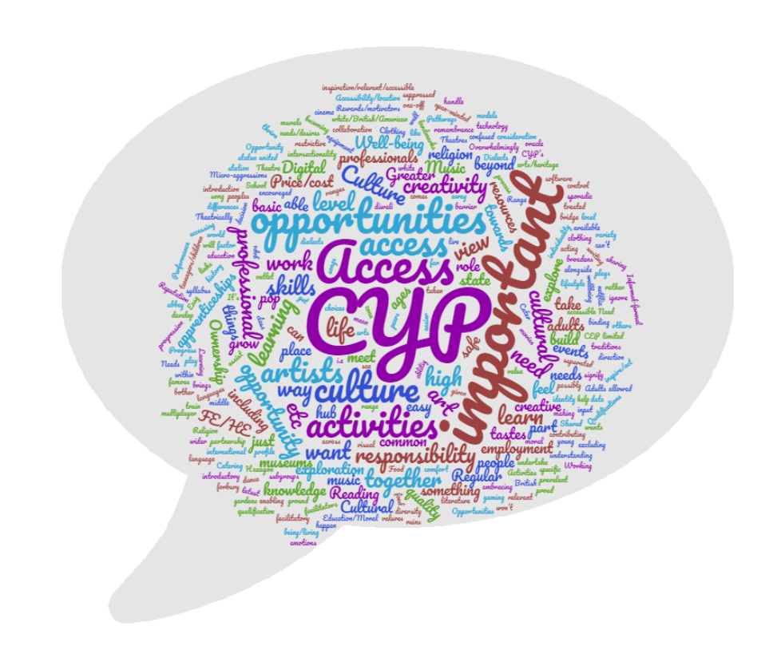
Culture can be hard to find, and should be more interactive with young people. There should be an aspiration for young people to shape culture, not just for them to have opportunities to access it, but be the drivers themselves and be decision makers. Culture is an interaction, not a static thing. Environmentalism is an important part of culture.
The full range of responses are given in Appendix 5.

Appendices

Appendix 1 Terms of Reference
Appendix 2 SWOT analysis
Appendix 3 Arts Award and Artsmark statistics
Appendix 4 Survey data
Appendix 5 Consultation workshop feedback

  - Appendix 1
Reading Cultural Education Partnership
Terms of Reference
2016-2019

Purpose and role of the group:
The purpose of the group is to drive forward a shared vision in providing high quality arts and cultural
experiences for children and young people1 in Reading; ensuring them the opportunity to aspire, achieve and
participate.
Outcomes
As partners working together the aim is to achieve the following:
· Ensure art and culture is strategically positioned to influence senior level decision making
· Increase the profile of art and culture for children and young people and advocate its benefits
· Ensure the Culture and Heritage Strategy, children and young people targets are developed and
implemented
· Create and implement a cultural education infrastructure to provide sustainable access to a diverse
range of communities and cultural activities, complementing the ACE creative case for diversity
· Collaboratively work with Reading CAN to provide access to artist, cultural organisations, best
practice and workforce development
· Support the ongoing art and culture activities for children and young people and develop new
initiatives where identified.
The Cultural Education Partnership (CEP) is responsible for commissioning any financial resource which will
actively contribute to the agreed outcomes. It is also responsible for identifying and generating revenue to
support outcomes.
Membership
Reading Borough Council
· Chair of Arts and Heritage Forum (Chair )
· Mayor
· Head of Culture and Economic Development
· Head of Education Services
· Children Services- cross sector representation x3 (e.g. youth service, children centres)
· Library Service Manager
· Reading Museum Manager
· Culture Development Officer
Community Engagement
· 1 leading representative of Reading CAN
· 1 representative from the Local Strategic Partnership
· 1 representative Cultural Partnership (Arts)
· 1 local artist
Education Engagement
· 1 representative from School Governors
· 2 head teachers (primary and secondary)
· 1 representative of further education (Reading College)
· 1 representative from Higher Education (University of Reading)
· 1 representative Music Education Hub
1 Aged 0-19 and up to 25 for children and young people with a disability
Core Strategic Partners
· 1 representative from Artswork
· 1 representative for the Reading Youth Cabinet
· 1 representative from the Health and Wellbeing Board
Other Partners
· 1 representative Police and Crime Commissioners
· 1 representative Housing Association
· 1 representative Thames Valley LEP
· 1 representative Business and Skills- UK CIC
Each role will be reviewed on an annual basis. The purpose of this is to ensure that the partnership
represents the communities changing views, bring new perspectives and innovation to the partnership.
Membership of the partnership will be by invite only.
Accountability:
Governance- Readings CEP is a formal partnership brought together under this Terms of Reference
document.
Working methods:
CEP members agree to:
· Work collaboratively towards the outcomes agreed
· Use an Outcomes Framework to plan project activity delivered individually and in partnership
· Share project ideas and learning with the CEP members at partnership meetings or within Reading
CAN to inform the development of the Outcomes Framework and the shared expertise of the group
· CEP members understand that there needs to be a long term commitment and collaboration in order
to ensure sustainability and longevity
Organisation
The venue for meetings will be held in Reading.
Meetings will be held on a quarterly basis
Decision Making
The partnership will be asked for decisions and recommendations on a range of cultural opportunities in
Reading for children and young people. When voting the majority carry’s the vote, if the vote is tied the
chair has the deciding vote. In the event that a board member is unable to attend their substitute can
attend to vote on their behalf or they can vote in advance of the meeting by sending their vote through to
the chair.
Review
The CEP will review its outcomes, membership and activity on an annual basis.
Changes
This is intended to be a working document and as changes are made it will be circulated to the partnership.

  - Appendix 2
SWOT analysis
Provided below is a subjective SWOT Analysis that summarises some our initial discussions. This document will be built on throughout the evaluation and incorporate policies and strategy documentation and feedback from the online surveys and interviews. It is subjective, because much is open to interpretation. Where appropriate, strengths and aligned weaknesses have been identified together.
STRENGTHS | WEAKNESSES
The effectiveness of RBC coordinating the partnership and championing its role. | There is a perceived overreliance on the RBC Cultural Development Officer to coordinate partners and keep momentum.
There are examples of where partners have pulled together to apply for funding e.g. the libraries funding. | There are a range of funding opportunities available, but currently there isn’t resource to develop a response from the partnership.
New partnerships and collaborations have been brokered as a result of the CEP | The partnership now needs to focus on pathways and journeys through accreditation, other skills opportunities or progression between partners or other initiatives.
Artswork – CEP has generated 3 large-scale £50k project grants and smaller grants at £4k and £5k to support delivery. | The partnership needs more data to understand the ‘drop-off’ rate of Arts Awards and to understand why this is happening.
Arts Awards ‘objective’ and sub-group– the partnership had clear tangible targets around this and effectively implemented a plan to drive activity. Numbers and awareness have increased as a result. | The partnership hasn’t done an analysis of the key strengths, skills and experiences of the partners to ensure partner roles and contributions are most effective.
There are a range of community, statutory and cultural partners that sit on the CEP and are committed to achieving the overarching objectives, each bringing their own strengths. | The partnership hasn’t collected data that shows which schools are currently engaging with cultural activity. It doesn’t know where there are gaps to target activity.
Where there are tangible projects, CEP partners work well together e.g. signposting the reading challenge. | The partnership hasn’t engaged with or lobbied the careers services to raise awareness about creative industry professions.
The CEP has a strong internal brand, which organisations are keen to be a part of and do ask about it. | The partnership does not have a dedicated external website or branding.

OPPORTUNITIES | THREATS
A new ACE strategy (currently undergoing consultation) outlines a greater focus on individual creativity, creative industries, etc. | Arts is continually overlooked in comparison to other STEM subjects. There is need for more lobbying.
Data sharing – the partners on the CEP gather a range of data that when pulled together could provide valuable evidence for the Partnership’s case for support | Youth voice continues to be underrepresented on the partnership. It is easy to get this wrong.
CEP evaluations are being carried out across the UK, and so there is an opportunity to learn from others and implement successful and proven ideas increase connections between partners e.g. ‘cultural passports’ | CEP does not realise the funding it needs to keep momentum and deliver the projects it needs to as part of a new strategic plan.
Community and family-based approaches have not been explored by the partnership as yet. Approaches used by programmes such as Creative People and Places can help to inform approaches. | The CEP doesn’t connect to the strategic groups and committees it needs to in order to affect change in cultural education.
Approaches to engage vulnerable young people up to age 25 have not been fully explored by the partnership as yet.
A better understanding of CEP partners’ strengths, resource and key skills can bring new ways of working.
A strong brand and web presence could bring increased audiences to the partnership’s work with cultural education.
The legacy of Great Places should feed into CEP
Key audiences such as teacher networks and schools’ improvement teams are untapped potential resources
Digital/tech funding initiatives currently being developed and funded by the LEP
Shared measurement approaches and pooled evaluation tools to collect data can help provide clarity of progress against key objectives and outcomes

  - Appendix 3
Arts Award and Artsmark statistics
Reading Cultural Education Partnership started in January 2016. It aims to allow every child and young person in Reading to have the opportunity to aspire, achieve and participate in high quality arts and culture.
(Definition: the work of the CEP focuses on children and young people aged 0-19 and vulnerable young people up to the age of 25).
Reading Cultural Education Partnership set a target of supporting 750 children and young people to gain accreditation in an Arts Award by August 2019.
Arts Award is a range of unique qualifications that supports anyone aged up to 25 to grow as artists and arts leaders, inspiring them to connect with and take part in the wider arts world through taking challenges in an art form - from fashion to digital art, pottery to poetry.
Artswork the SE Bridge organisation for Arts Council England confirmed the following Arts Award data for Reading.
Discover | Explore | Bronze | Silver | TOTAL
1277 | 99 | 25 | 43 | 1444
(January 2016 – November 2018)
The Cultural Education Partnership can take account for 1355 of these qualifications via partnership working and various financial investments. Organisation and delivery breakdown is as follows;
Number of Arts Award | Organisation
823 | Readipop
436 | Jelly in partnership with The Museum of Rural Life, Reading library Service and The Rock Academy
63 | Reading Rep in partnership with Reading College
6 | Reading Museum

  - Appendix 4
Survey responses
The responses to the above generated the following evaluation of the work of the CEP from 2016-2019:
Evaluating the Reading Cultural Education Partnership

Responses to the online survey
Collated Monday, October 21, 2019

Q1: Name of organisation.
7 organisations responded to the survey:
Reading Rep
Jelly
Reading Museum
Dance Reading
CultureMix Arts Ltd
Readipop
The Rock Academy Foundation

Qu 2: How many young people (aged 0-19 or vulnerable young people up to the age of 25) have you engaged in the last three years (between September 2016 to August 2019)?
Answers demonstrated large numbers of engagement, however some organisations were able to report exact figures whereas others did not collect this data.
Thousands;
3,000 plus;
for 16-17 total was 87231 (includes loans and visits) for 17-18 it was 76504, for 18-19 it was 88382 and for Q 1 of this year it is 3706. this includes both our outreach with loan boxes and our school visits, and more recently we have tracked family workshops too. We don't always track the upper age groups although we are getting better at tracking those.;
Directly - approx 300, Indirectly – thousands;
6,325;
3,640;
100-200 young people across all of our activities.

Q3: If applicable to your organisation, please tell us about the range of cultural activities you deliver for young people (tick all that apply)

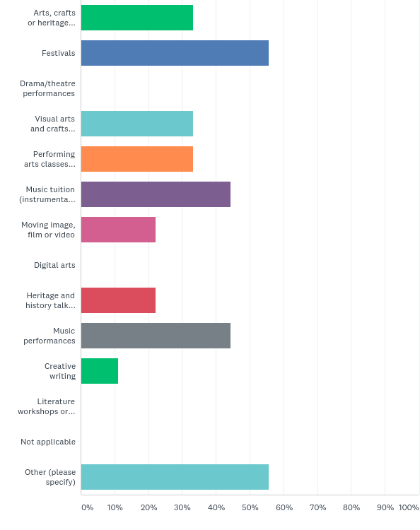

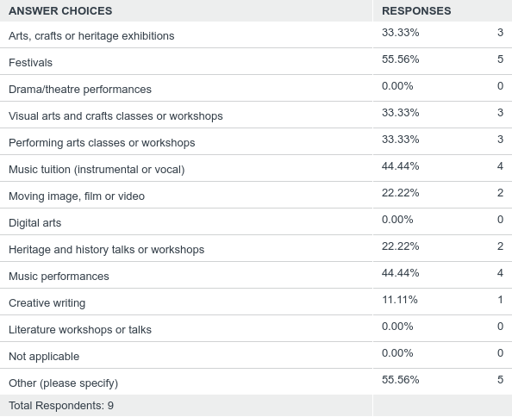

Q4: If applicable, where do you deliver cultural activities/work with young people? (tick all that apply)
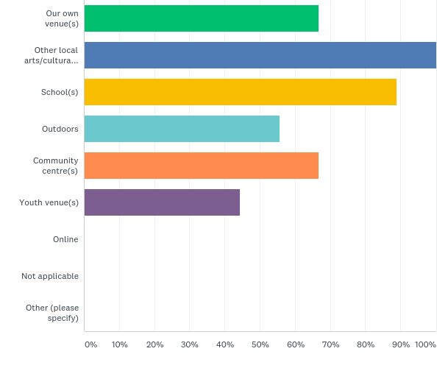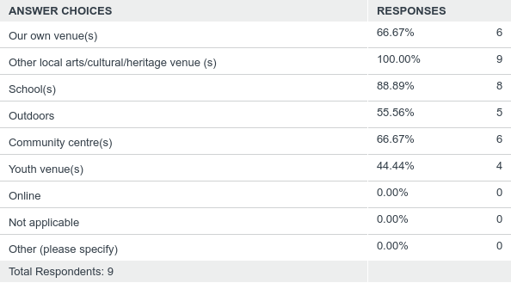

Q5: How many people do you employ (FTE)?
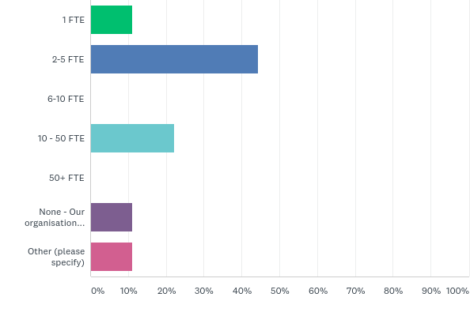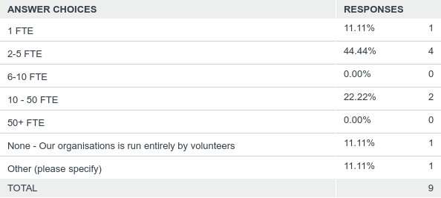

Q6: How many volunteers support your organisation?
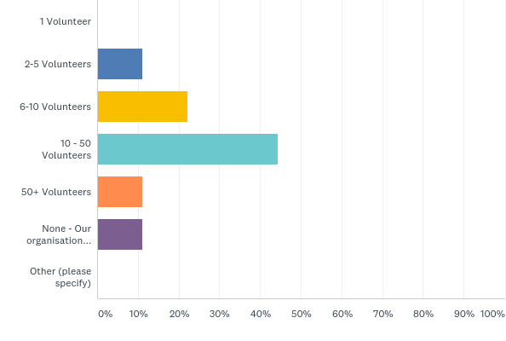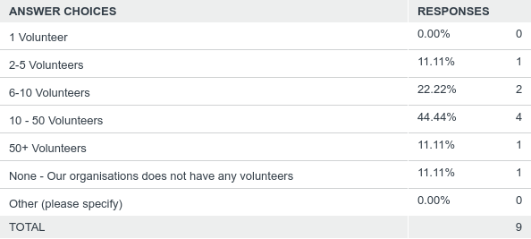

Q7: Do you consider your organisation to be ‘diverse led’? i.e. more than 50% of your management are from a BAMER background, disabled, female or are LGBTQ+
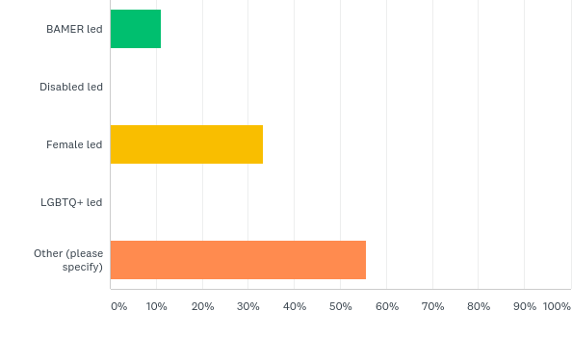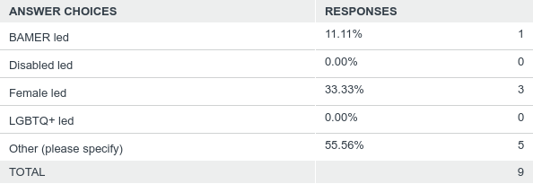

Q8: How are you funded?
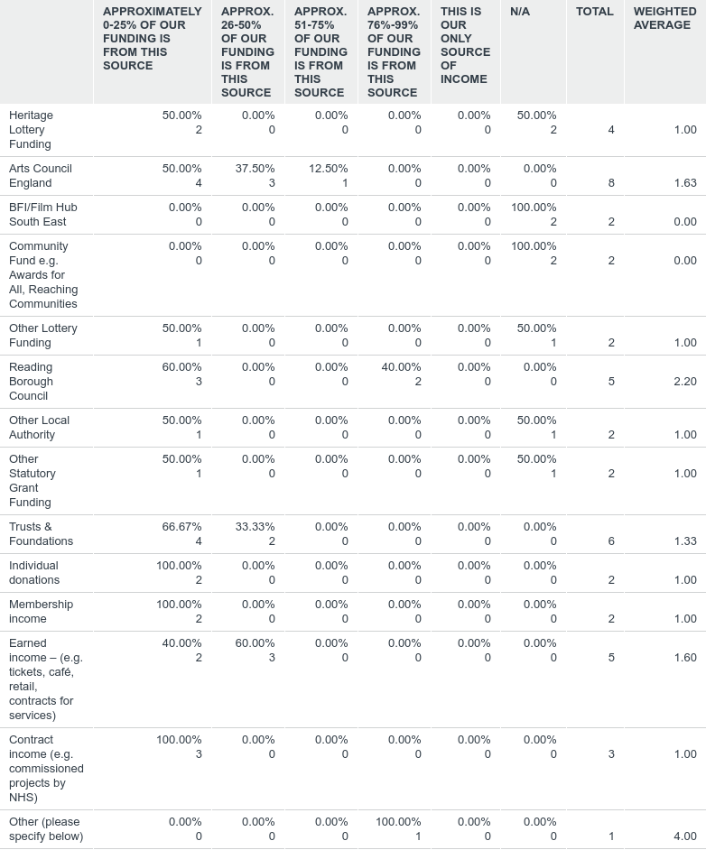

Q9: Please tell us which Primary Schools you have engaged with in Reading between September 2016 and August 2019? Primary schools listed below are presented in alphabetical order.

Q10: Please tell us which Secondary Schools you have engaged with in Reading between September 2016 and August 2019? Secondary schools listed below are presented in alphabetical order.

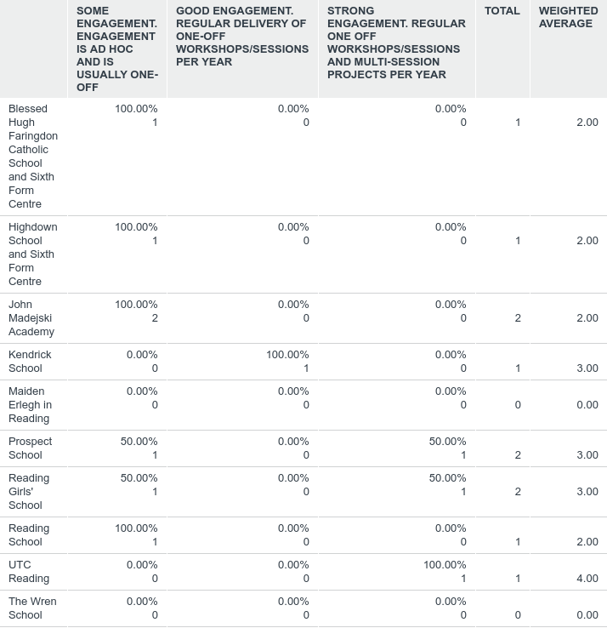

Q11: Please tell us which Special Schools you have engaged with in Reading between September 2016 and August 2019? Special schools listed below are presented in alphabetical order.
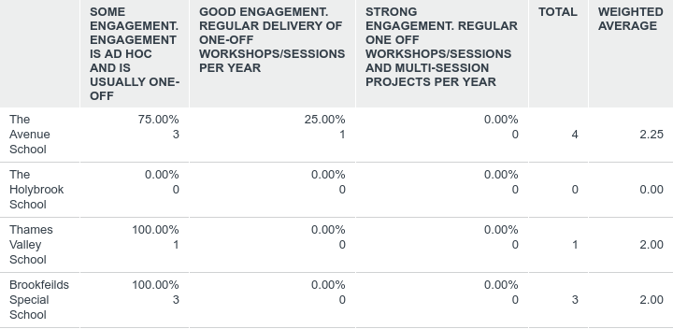

Q12 Consider the overarching aim of the Reading CEP between 2016 and 2019: To allow every child and young person in Reading to have the opportunity to aspire, achieve and participate in high quality arts and culture, and to develop a collaborative, sustainable infrastructure to maintain such engagement.What, in your view, have been the key successes for the partnership in terms of achieving the overarching aim?
KEY SUCCESS 1
1 Arts Award scheme has been very successful – positive results and the number of young people. We got funding through the CEP was able to get the bronze or silver Arts Award and we organised celebration. Now on the arts award board. Put in touch with ArtsWork and brokering
2 Building up the offer of Arts Award in primaries with Artwork. After their pilot project, Jelly now offer this as standard to primary schools they work with. Discover level. Encourage active participation of 10 hours each, more than one engagement with each child.
3 Better recording of engagement by organisations
4 The partnership has supported arts organisations to work with more schools, reaching more children and young people
5 Increasing Arts Award participations
6 Increasing the number of Reading schools we work with and the depth and quality of the work completed with the young people at these schools
KEY SUCCESS 2
1 Individually, we have got to know other organisations and we are having conversations with other organisations. Work in partnership. We work closely with Jelly on Christmas show. Cultural commission bid – through the CEP we have been as a result of the partnership.
2 Funding – new Schools connect programme working with 10 schools to form a network of excellence working towards ArtMark status. Will be working in schools over 2 years to embed the arts in all areas of education and providing CPD for teachers. Encouraging critical thinking.
3 Starting to be more organised in terms of a joined up approach to our offer across the town
4 The CEP fosters collaborative working, in a competitive landscape.
5 Improving dialogue between organisations
6 More collaboration, especially between smaller organisations
KEY SUCCESS 3
1 Sub groups are useful to bring in non-arts sector into the meetings – youth organisations can attend these and understand the offer.
2 working together to make sure we offer high quality offer to children in our area
3 the CEP has provided a framework that enable engagement to be understood by schools, there is the perception that there is 'something in it for them'
4 Providing an agreed strategy for organisations to support which assists with finding funding
5 The large number of young people who have gain an Arts Award through working with a Reading arts organisation

Q13 What have been the key challenges faced by the partnership in terms of achieving the overarching aim?
KEY CHALLENGE 1
1 Time is an issue – using the meetings for useful dates. Be more strategic. Many arts organisation is small and people are attending in their time.
2 not sure. Jelly have only seen positive things come from CEP
3 finding ways of recording data that match - we all use different ways of recording as we have different funders to please!
4 Arts landscape in Reading is highly competitive and there is a lot of silo working. This really needs to be overcome in order for arts orgs to navigate challenging financial times
5 Artsmark take up
6 Securing funding to ensure that projects can continue
KEY CHALLENGE 2
1 Arts Award was so successful that the market is so saturated.
2 sharing our 'customers' we all need to do our own thing, and yet find ways to share the best outcomes and support each other
3 The CEP is led fantastically well by Kayleigh Hodges, but without that energy behind it, it would lose momentum. This isn't a sign of lack of sustainability, just the reality of large and diverse partnerships such as this.
4 Schools engagement with the CEP
5 Securing meetings with some schools to discuss project/collaboration opportunities
KEY CHALLENGE 3
1 Don’t know how easy it is to become a part of the CEP – Is it actively looking for organisations and is it a closed shop.
2 Next steps - ensuring everyone is working towards strategic goals for Reading and its children and young people as a whole, rather than simply finding ways to progress their own organisations
3 Youth engagement

Q14: How successful do you perceive the partnership has been in meeting its delivery objectives:
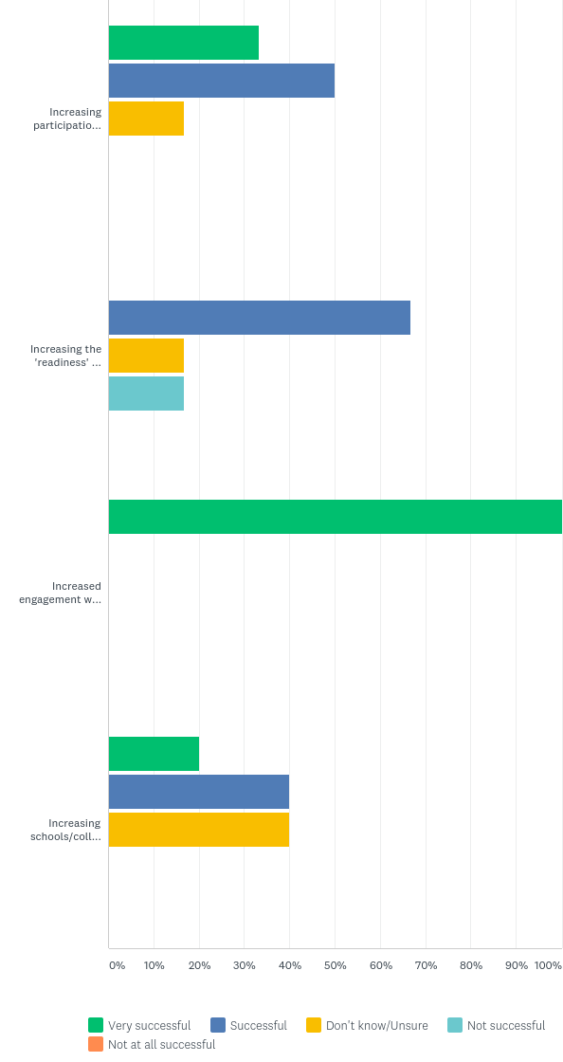

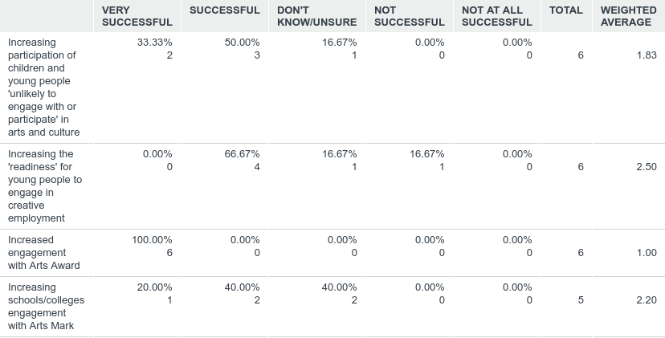

Q15 Please share up to three cultural developments for children and young people that you would like to see in Reading in the next 3 years. These might include your own development plans, art form or heritage specific, Big Ideas, or broader aspirations relating to participation or engagement, and may relate to facilities, resources or activity.
DEVELOPMENT 1
1 Tackle the issue of arts subjects in schools. Want to see more collaborations between art forms and pull resources.
2 Have a rolling project of Schools Connect. After these 10 schools, work with another 10 schools etc. Schools sharing learning, sitting on the CEP. Thus, Reading becomes a centre of excellence for creative work in Primaries (then on to Secondaries). Take education away from the formulaic and back to playing/creativity.
3 A chance for all young people to hear about the amazing history of their town
4 I'd like to see the roll out of Arts Award/Mark and training to dance schools and teachers
5 Increase youth engagement
6 A focused summer programme with activities that cover many creative disciplines. Some great work was completed by the RVA this summer, it would be great if we could continue and expand on this
DEVELOPMENT 2
1 Strategic level – bigger voice in campaigning around promoting arts in schools.
2 Increase pride in Reading as a creative place. Make creative reading known more widely than the small sector that currently knows and celebrates it. Be more visible.
3 support for schools to enable them to find out what is on offer in the town
4 A small, focussed strategy group, with a mandate for improving arts delivery in schools
5 Increased support for young people who are NEET or experiencing poor mental health
6 The Rock Academy would like to secure more funding to both work with community centres and also fund young people to take part in our band experience and instrumental tuition programmes.
DEVELOPMENT 3
1 Help young people to use the arts as a platform to have their voice heard – arts is a great way to find that what
2 A cohesive CPD programme for teachers in cross-form arts, from a partnership of organisations, working together to upskill teachers.
3 Increased employment/development opportunities.
4 A varied after school programme, with support from mentors, etc. Some work has been started by the RVA on this, it would be great if this could be taken forward.

Q16 Please share up to three changes that you feel are needed to enable or facilitate the developments you have identified
ITEM 1
1 Collaboration – encourage collaboration in the delivery. Holistic arts projects. More celebration in bringing groups together.
2 Funding for Schools Connect to become rolling. The resource is there in terms of participatory artists, just need funding.
3 we need an arts/heritage schools officer in the town who can coordinate and support the schools and the CEP organisations to get the best out of what we have on offer!
4 A small, strategy group would be beneficial to support the needs of the larger group and subgroups
5 Increase youth provision and staff able to support youth engagement in Reading.
6 Access to larger funding sources to support multi-year multi-discipline activities
ITEM 2
1 Campaigning – CEP is connected to the Council with the relationship to the schools. It might be easier to get in to schools – engage with headteachers. Help us to understand more about the teachers. Brokering conversations and promote.
2 Make creative reading more visible – a Time Out publication, or flagship centre. An Incubator to allow creativity to thrive and be visible, places and spaces with high profile. Suggested like Arnolfini in Bristol.
3 More platforms for sharing the learning from the CEP, in terms of partnership working, what works what doesn't, what are the benefits, how to support orgs in working in partnerships more effectively
4 Better engagement by CAMHS, Police, YOS, and RBC Education.
ITEM 3
1 Working with Brighter Future for Children and Youth Services. Connected to decisions.
2 More platforms to celebrate existing work, that would encourage teachers and others working with children and young people to engage with organisations who are part of CEP.
3 Maintain levels of schools’ engagement but provide more creative/musical progression routes for children

Q17 Briefly (in a couple of paragraphs) tell us about your organisation's strengths, skills, experience and knowledge that you bring to the Cultural Education Partnership
RESPONSES
1 Our skills are that we work directly in schools (at the coal face!) delivering work so we understand the challenges that teachers face and how we can support them. We bring that knowledge of how we can work with schools and therefore communication. Plus, we have good artists and we work with emerging artists to elevate them to work in Reading.
2 We are skilled in delivering heritage/history workshops/sessions for children from KS1-KS3. We are working in partnership with the MERL to help to expand that offer and to engage with young people in a broader context. we will be working on our new Youth Manifesto soon. We have many people here who have years of experience and a vast array of knowledge!
3 We are an umbrella organisation. Whilst we do deliver work directly with young people as part of our festival work, mentoring programme and support for young and emerging artists, our strengths lie in supporting the over 150 dance schools who all work with children and young people across Reading, both within and beyond schools. We spend extensive time listening to the sector and shape our activities to meet their needs. We have particular experience in supporting and mentoring young dancers, providing them with support and guidance to continue their work, develop skills, find collaborators and create platforms to showcase work. Our directors all work with schools and young people in other capacities as well as within Dance Reading, and so bring a diverse experience of arts work in schools and informal education settings. Our membership is broad and diverse and gives us an extensive picture of the current state of dance in schools and settings across Reading and beyond
4 Readipop is one of Reading's NPOs with over 20 experience of delivering projects with children and young people. See Readipop.co.uk
5 The Rock Academy delivers high quality music/music technology-focused activities in the Reading area. Our Band Experience allows young people to work with experienced coaches to write new original material and perform it at regular concerts and community events. Our instrumental tuition (in both private and school settings) enables young people to develop on their chosen instrument and take grades in order to celebrate their progress. Our community work is varied and focuses on music performance and music technology. Our focused offer means that we are able to produce high quality work, and this is evident in our end-of-term shows, videos and recordings. We are very able collaborators and can adapt our offer to suit a particular group, project or community setting. Our head of academy also has extensive experience of the further education sector and is an experienced Arts Award advisor at all levels.

Q18: How successful do you perceive the partnership has been in meeting its other objectives:

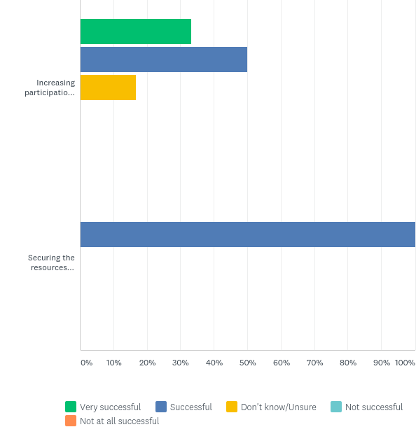
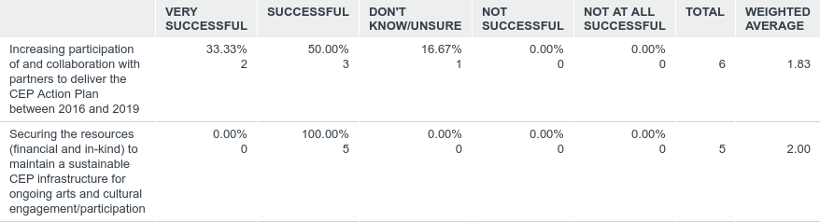

Summary Evaluation drawn from survey responses:
Objectives from 2016-19:
By August 2019 5,000 children and young people who were previously unlikely to engage with or participate in arts and culture will have engaged with and participated in an activity* | Thousands of children and young people are engaged with by partner organisations, however there is no data to identify if they were those unlikely to engage in activity previously. The majority of schools and colleges in Reading were engaged with, with only 4 schools that had had no engagement in the last 3 years, so it is likely that these children and young people are being reached.
Over the term of the CEP Action Plan 1,500 young people will have undertaken training, and achieved skills and appropriate accreditation, making them ready to seek employment in the cultural sector, or to use creative skills in their chosen employment field** | This data has not been collected.  There is some evidence of work experience provided for young people by cultural organisations in Reading.
Between September 2016 and August 2019 1,500 children and young people in Reading will have engaged in Arts Award with at least 750 achieving accreditation at one or more levels | Survey respondents say that Arts Award at Discover level has had large take up, however there are no figures for this.
Over the term of the CEP Action Plan 30 schools and colleges in Reading will have gained Artsmark status | 15 Schools have registered to work towards Artsmark, including those working through the Schools Connect programme. This represents 23% of schools in Reading.
Between September 2016 and August 2019 20+ partner organisations will actively participate, in collaboration, in delivering the CEP Action Plan | A number of partner organisations have actively collaborated.  In terms of Artswork investment into Reading CEP:  9k transition funds 2018, 10k start up funding 2015;  Total of £81k Partnership Investment over 2 applications levering in £97,700.
By August 2019 a further 3 Year CEP Action Plan will have been developed and resources secured to maintain a sustainable infrastructure for comprehensive ongoing arts and cultural engagement and participation from Reading’s children and young people | In development

* By targeting activity in areas of deprivation this objective can be focused and evaluated
**Meaning that young people from Reading will have achieved relevant accreditation through arts related degree programmes, BTEC Arts programmes, Silver or Gold Arts Awards, Level 5 or above Music Grades, specific and recognised theatre and dance awards, or equivalents
  - Appendix 5
Results of consultation Lego® Serious Play® workshops
Following the survey, key themes to consider were drawn out and these formed the basis of the next stage of consultation, the Lego® Serious Play® Workshops. The consultation sessions were also informed by the new Ten-Year Strategy produced by Arts Council England, in order to ensure that the strategy was relevant to the wider cultural landscape.
3 questions were identified for the consultation group to consider:
- Creative people: What will the cultural landscape of Reading look like 3 years from now that enables ALL children and young people to develop & express creativity throughout their lives?
- Cultural communities: 3 years from now, how will culture and creativity have a broader impact on children and young people?
- A creative and cultural country: What does an innovative and collaborative CEP look like 3 years from now?
Attendees at the workshop then used Lego® to work together on building their vision, and from this they were able to articulate how they had explored the questions and were then able to identify a number of objectives for each of the three themes.

Attendees at the Lego® Serious Play® Strategic Plan Workshop:
Culture Development RBC
Rock Academy
Connect Reading
Reading Museum RBC
Reading Fringe Festival
Dance Reading
Artswork
CP
RBC Library
RBC Children Care
Berkshire Maestros
Aspire2
Reading Rep
RBC Project Manager

- Creative people: What will the cultural landscape of Reading look like 3 years from now that enables ALL children and young people to develop & express creativity throughout their lives?

- Gatekeepers or blocks to young people accessing culture: bureaucracy, fear of the unknown, plus poverty and deprivation
- Must empower young people to advocate to other young people
- Allowing young people to work with organisations to shape their own direction
- Give young people more opportunities to experience diverse culture
- A need to take care of culture for the future / environmental concern
- Target early years through parents: at primary age, home environment is a bigger influence than school
- NEET pilot projects
- Work in partnership with organisations already working with hard to reach, not just within cultural sector
2. Cultural communities: 3 years from now, how will culture and creativity have a broader impact on children and young people?
- A gateway to two paths: - careers in culture, with a clear path; character development/transferable skills by taking part in culture
- The pathway has links to corporate world
- Arts Award throughout; Art Award needs to be communicated as a series of stepping stones
- Arts Award able to be achieved through other routes outside of school
- Gateway starts at early years and the pathway goes through to successful employment
3. A creative and cultural country: What does an innovative and collaborative CEP look like 3 years from now?
- CEP branching out to more organisations, and schools’ part of the CEP
- Governance above the CEP – needs the flag waving
- Needs to be a shared role to steer the CEP
- Clear operational roles and strategic roles
- young people are the face of the CEP and advocating for it
- The steering is formed of a diverse group of people representing the community
- Widen representation on the CEP, and have clear roles between strategic function and project delivery

[YP Lego workshops feedback] available in a separate PowerPoint doc.

